**Code Snippet:**

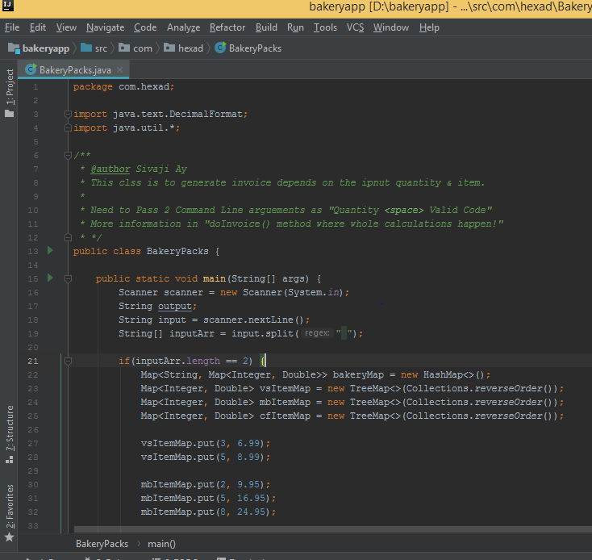

**OUTPUTS:**

**We should pass command line arguments as Inputs in Question. Green Color in below screenshots.**

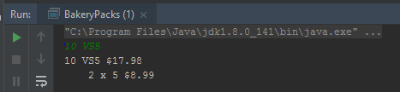

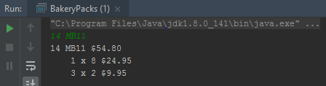

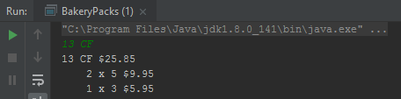

Structure:

